April 9, 2014
FILE MEMORANDUM
FROM: Gary Fredricks, NOAA Fisheries
SUBJECT: The Dalles Dam Split Flow Change Request Form
I have taken a shot at further refining the draft change form on The Dalles Dam split flow issue that was originally submitted by the Corps’ NWP Fisheries Section back on September 17, 2013. This is a work in progress. I have added some new language to the proposed change form that identifies specific criteria for the action. I have also started to fill out the justification section with additional information regarding these criteria including several questions that need to be addressed by the FPOM subgroup working on this issue. This group is scheduled to meet after the April 10 FPOM meeting and I propose this draft change form as the starting point for that meeting.
DRAFT FPP Change Request Form
Change Request Number & Title: 14TDA009 Split Flows
Date Submitted: September 17, 2013
Project: TDA
Requester Name, Agency: NWP Fisheries Section
Location of Change - FPP Project and Section:
TDA 2.1. Project Operations – General. Add new paragraph 2.1.4.
Proposed Changes (in track changes to existing section):
Entirely new section under Section 2.
2.1.4. Project Split Flow Distribution. If adult and jack salmonid counts equal or exceed 25,000 fish per day after August 31, the Project will provide 10 kcfs spill daily for 12 hours between 0400 and 1600 in an attempt to balance adult passage between the east and north fish ladders (TDA-E and TDA-N, respectively). This operation will continue until TDA adult and jack salmon counts fall below 20,000 fish per day. The spill pattern will be modified from the normal spill pattern as indicated in Table XXX.
Justification for Change:
The rationale for this change follows the same rationale that lead to the powerhouse flow split at Bonneville Dam (FPP BON Section 2.1.1.1.). Uneven flow distribution at The Dalles Dam, like at Bonneville, can lead to overcrowding in one of the project fish ladders. The situation at The Dalles is unique, however, since the north ladder at this project normally passes a low percentage of the project passage, either due to highly turbulent entrance conditions under normal 40% juvenile spill levels or due to lack of attraction flow during no spill conditions (see Tables 1 and 2). While crowding is less likely at The Dalles Dam than at Bonneville Dam due to significant tributary turnoff in the Bonneville Pool, there is still the potential for overcrowding the east ladder, particularly when there is a strong run of upriver bright fall Chinook, as seen in the late summer of 2013 (and expected in 2014).
Table 1. Spill season (April-August) North Ladder passage percentage for 2010 – 2013.
 | 2010 | 2011 | 2012 | 2013 | Average
Adult Chinook | 31 | 17 | 21 | 28 | 24.3
Jack Chinook | 18 | 6 | 7 | 15 | 11.5
Steelhead | 27 | 10 | 12 | 16 | 16.3
Sockeye | 24 | 3 | 2 | 21 | 12.5
Average | 25 | 9 | 10.5 | 20 | 16.1

A limited spill test in 2013 was conducted at the Dalles Dam in an attempt to encourage higher use of the north ladder. A memorandum summarizing that test is attached. While the test was not conclusive, it did suggest that a limited amount of spill could encourage additional usage of the north ladder.
Earlier spill tests were conducted by the Corps’ FFU in 1993 and 1994 (Jonas and Stansell, 1995). The 1993 test was conducted with 1,500 cfs spill flow from bay 1. This condition was tested against zero spill. The test was conducted with two day blocks with each condition lasting only one day. The fall 1994 test compared passage counts with a similar two day block design although this time the zero spill day was paired with a 4.5 kcfs spill day. The distribution of passage was monitored at the ladder count stations. While sockeye did appear to respond to the summer 1993 test, neither test significantly improved passage distribution of late summer/fall migrants.
While the 1993 and 1994 tests did not show a significant increase in passage with small amounts of spill, there still are some fish using the north ladder during the no-spill season. Analyzing no-spill passage in September through October in recent years indicates an average of 6% of the adult Chinook project passage occurs via the north ladder (Table 2).
Table 2. Percentage of adult Chinook passage via the North Ladder, September 1- October 31.
 | 2010 | 2011 | 2012 | 2013 | Average
% N. Ladder | 6 | 5 | 7 | 6 | 6

During the normal spill season, when 40% of the river flow is spilled, adult Chinook passage via the north ladder can be substantially higher than it is without spill. Figure 1 indicates the daily north ladder passage percentages for April through October for the past four years (years since the spillwall was completed). These data indicate that Chinook will pass the north side in significant percentages when enough spill is provided. At spill levels as low as 30 to 40 kcfs, the distribution of adult Chinook passing the north ladder is in the 20 to 50 percent range.

Figure 1. Percent North Ladder Passage vs. Daytime Spill Volume. Each data point represents a single day of passage during the four year period. The trend line is a fourth order polynomial line which indicates the central tendency of the data fairly well.
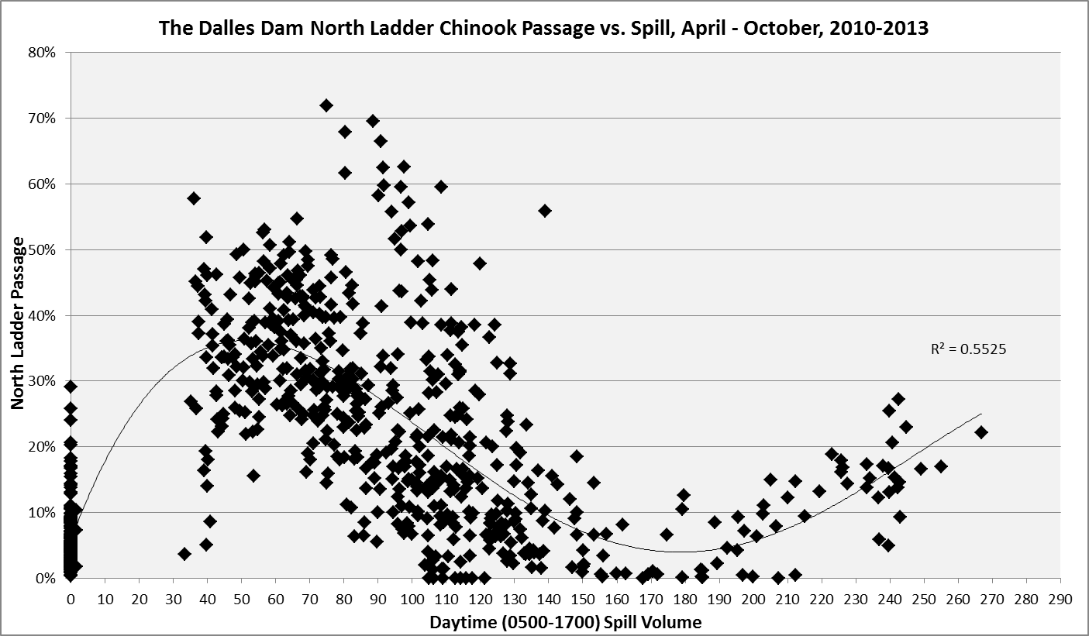
? 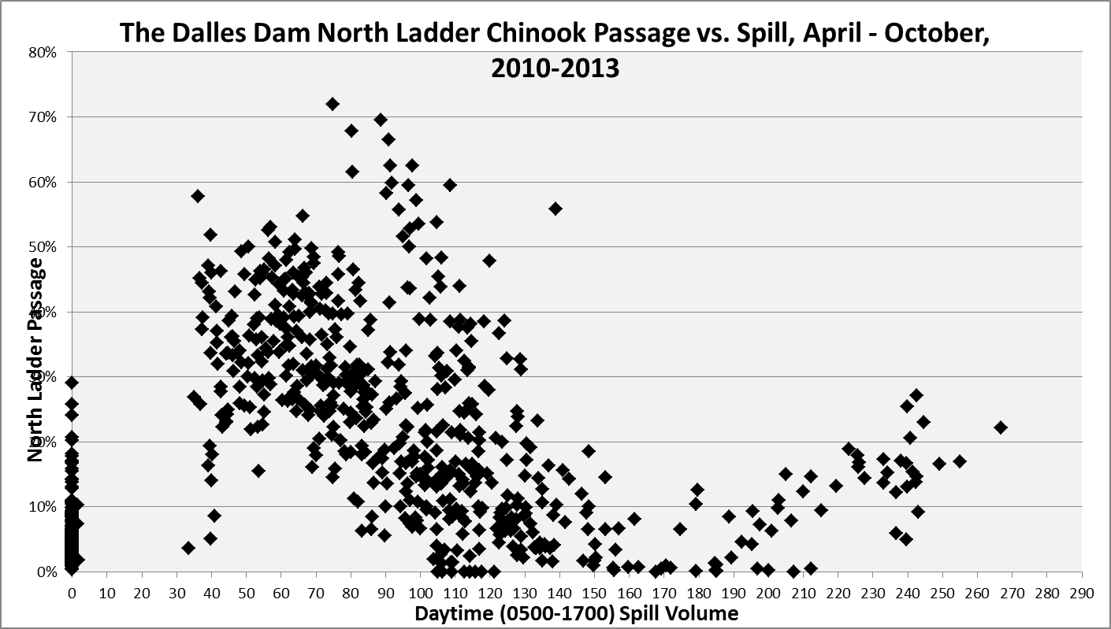
The question of course is what might happen to fish distribution in the zero (or 4.5 kcfs) to 40 kcfs spill range, particularly at the low tailwaters typical during the late summer/fall no-spill period. Will passage increase incrementally as more spill is provided or is there a spill flow threshold after which fish move en mass to the north ladder? These questions should be examined during the 2014 non-spill passage season with a two (or more) spill treatment test. The available data examined in this analysis would suggest test spill levels of more than 4.5 kcfs and less than 40 kcfs. I suggested 10 kcfs as a base starting point in the proposed FPP language, however, this number should be verified and adjusted as necessary based on the results of the in-season test.
The question of what fish passage trigger to use should be examined more closely. The capacity of the ladder system at this project is unlikely to exceed that of Bonneville Dam given the ladder usage issues, thus I used the Bonneville trigger for now. We should use the same methods used for Bonneville to calculate this value for The Dalles Dam.
The daily timing and duration of spill is also an issue that deserves more consideration. I chose a twelve hour spill period starting at 0400. Starting spill this early should give fish a chance to key in on the north ladder as they start to pass the project. However, this assumes fish are in the vicinity of the spillway and north shore and have the “opportunity to discover” the attraction spill. The duration of spill was simply chosen to provide attraction over the bulk of the daylight primary adult passage hours. Further investigation of the available radio tag data is needed to help refine these values. Also, the RT studies to be conducted this year should be designed to help with these questions.
Another question is what spill pattern should be used for the attraction spill. The spill table provided in the current FPP is based on best downstream passage for juvenile migrants, not upstream passage for adults. A pattern that starts at bay seven may not be appropriate for adult attraction. Also, gate openings should be sufficiently open as to provide a distinct flow signature downstream of the spillway without blocking fish access to the north ladder entrances. The current four foot minimum opening should be sufficient, however, this should be examined more closely with adult attraction in mind. Years ago, some work was done on an adult spill pattern with the current wall configuration. These investigations should be revisited with this late summer/fall adult passage issue in mind.
Gas generation will also be an issue with higher levels of spill. The Oregon waiver ends at the end of the spill season so TDG generated by this special adult attraction spill will need to be at or below 110% at the TDA downstream gauge. The data in Figure 2 summarize the TDG levels at this gauge generated by the spill levels that occurred in August of the past several years after the spillwall was installed. The year 2011 was omitted because spill and TDG levels were well above what we are considering the entire month. The data (with a second order projected polynomial trend line) indicate that the 110% TDG level likely occurs at about 25 to 30 kcfs spill. Spreading the spill out a bit from the normal pattern might help reduce TDG levels further.

Figure 2. TDG vs. August spill volumes.

Attachment 1.
FILE MEMORANDUM November 7, 2013
FROM: Gary Fredricks
SUBJECT: A Review of the 2013, The Dalles Dam Attraction Spill “Test”
On September 14 through 16, the Action Agencies agreed to try a limited amount of daytime spill to help reduce adult fish crowding in the East Ladder at The Dalles Dam. Flow in the amount of three kcfs was spilled for seven hours (0600 – 1200) from the north spillbay with the idea of pulling more fish to the North Ladder. The action was stopped after three days because the agencies deemed the action ineffective. While the effort was ineffective in relieving the East Ladder crowding, I believe the following data fail to support any assessment that the effort was not effective in moving fish.

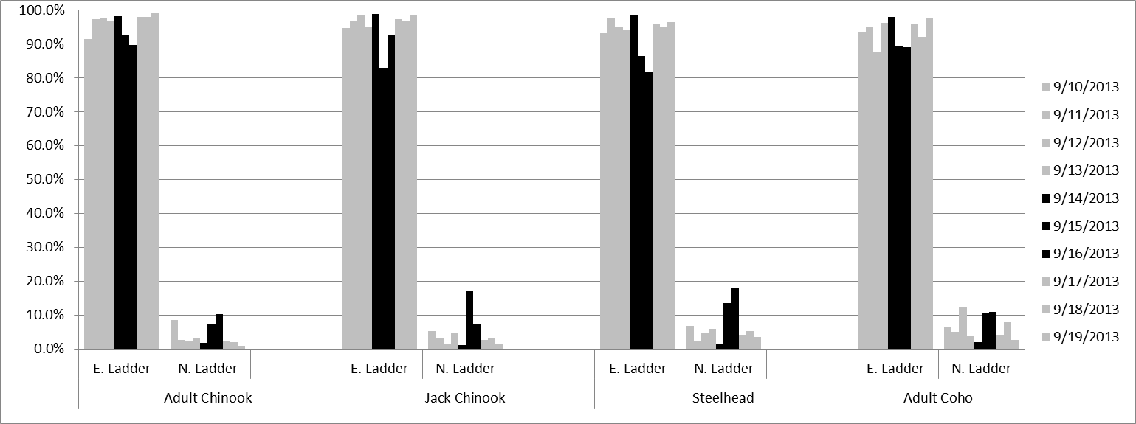

I believe the data clearly show what appears to be a response in ladder passage at the North Ladder as a result of the additional spill. The spill amount was quite small compared to the total river flow and the duration of the additional attraction spill was short and started when the fish would normally have already started entering the ladder systems. Even so, it appears that after a day lag time, several species of salmon did respond to the additional spill. This test is was certainly too short and too limited to provide any conclusive information. However, these results do indicate that any claims of failure may be unfounded and they also leave the question of whether a more determined effort would have been successful in reducing the east ladder crowding situation. A comparison of these data with the radio tracking data collected this year may shed additional light on this issue.

